SOC Fundamentals - Lab Report

Date: 19/05/2026
Difficulty: Easy
Category: Defensive Security (SOC)
Platform: TryHackMe

Overview

This lab

2. Toolset Used

Tool | Purpose / Function

3. What I did

A SOC (Security Operations Centre) is a facility operated by a security team who aim to monitor an organisations network and services for any malicious or suspicious activity to prevent any damage. This team will work 24/7 to ensure that the organisation is secure and not at any risk. The main focus is to keep detection and response intact.

Detection – This involves detecting vulnerabilities, unauthorised activity, policy violations and intrusions.

Response – This involves supporting the incident response team to minimize the impact and finding the root cause of the incident to stop it and prevent further attacks.

There are 3 pillars within SOC – People, Process and Technology. These pillars coexist to be as efficient as possible and provide the best security.

People – Human intervention is needed to focus on issues and spot harmful patterns and be able to alert and trigger a response. There are various roles in a SOC team such as SOC analyst level 1, SOC analyst level 2, SOC analyst level 3, Security Engineer and Detection Engineer. These all report to the SOC manager who reports to the CISO (Chief Information Security Officer).

Process – Each role has its own processes. One of these processes can be alert triage which is when a first responder triages and alert by answering the 5 W’s – who, what, where, when and why. Reporting is another process which is when an alert needs to be escalated, a ticket is assigned to it, and it includes details such as the 5 W’s, analysis and screenshots.

Technology – This pillar refers to the security solutions which help minimize the manual effort to detect and respond to threats. SIEM (Security Information and Event Management) is a tool used in every SOC environment to collect logs from network devices. Detection rules are configured in the SIEM solution which has instructions to identify suspicious activity. Machine learning is also being used here now to help with automation and enhance detection capabilities. The SIEM solution only provides detection capabilities in a SOC environment. EDR (Endpoint Detection and Response) gives a detailed real-time and historical view of device activities as it operates on the endpoint level and carries out automated responses. SOAR (Security Orchestration, Automation and Response) is a solution that helps automate security operations such as threat intelligence and vulnerability response. A Firewall, IDS/IPS and Antivirus are examples of other security solutions in SOC environments.

Practical – This practical part of the lab walks through the role of a Level 1 SOC analyst and shows how the SIEM solution can be used to view all logs for the alert and answer the 5 W’s.

WHAT – Port scan

WHEN – June 12, 2024, at 17:24

WHERE – Destination IP of 10.0.0.3

WHO - Source name is Nessus

WHY – Intended by the security team

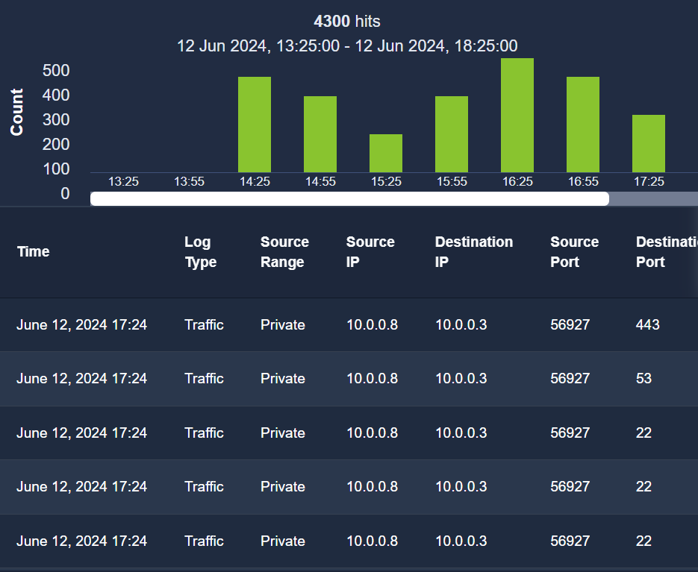

4. What I’ve learned

- Fundamentals of SOC
- Pillars of SOC – People, Process and Technology
- Roles of SOC – level 1-3 analysts, detection engineer etc
- Security Solutions of SOC – SIEM
- Practical example of looking through logs on SIEM platform to investigate an alert

